

***LAB REPORT 4***

***Muhammad Rafay***

***20P-0018***

***Computer Networks***

***Sec A***

**Task 1:**

Start pinging from PC0.

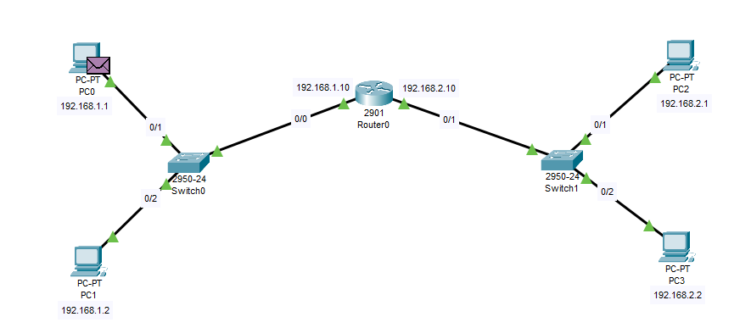

**TO SWITCH.**

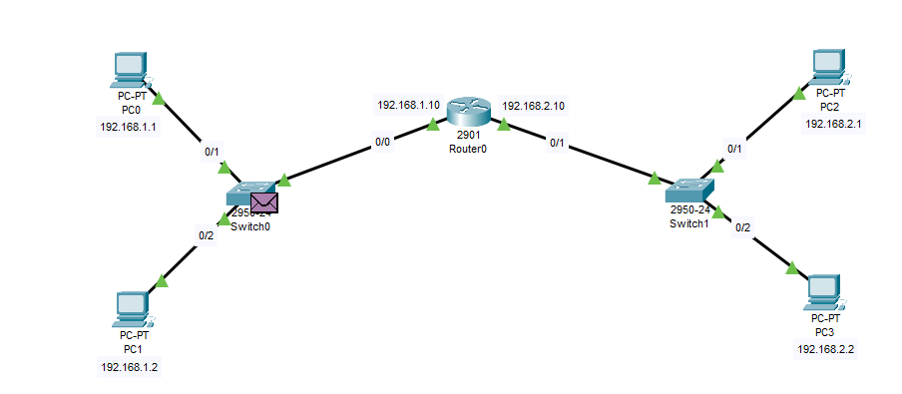

**SWITCH0 TO Router0.**

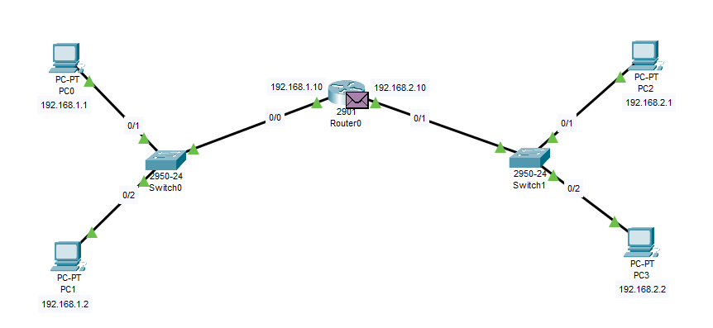

**Router0 To Switch1.**

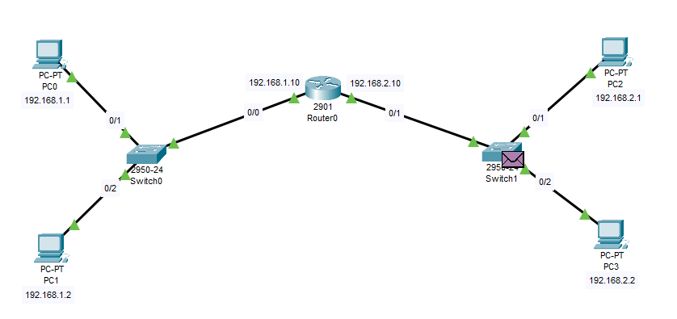

**Switch1 to PC2 & PC3.**

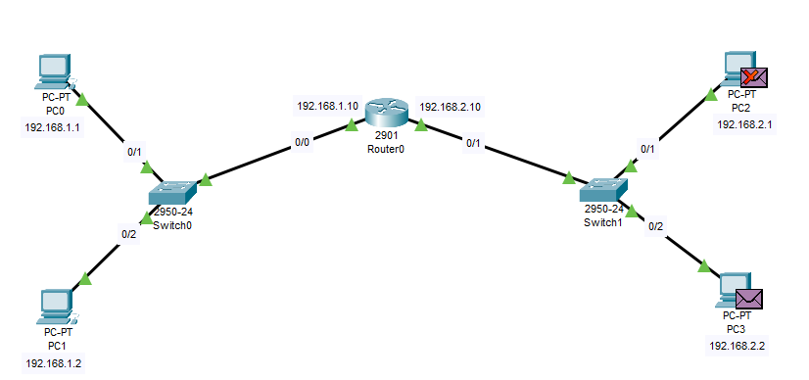

**Authenticating Back to PC0**

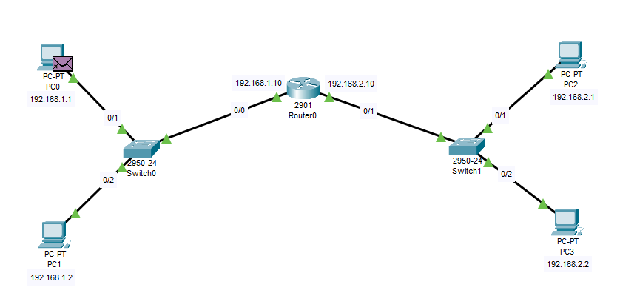

**TASK 1.**

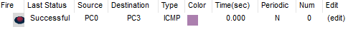

**TASK2.**

**Topology**

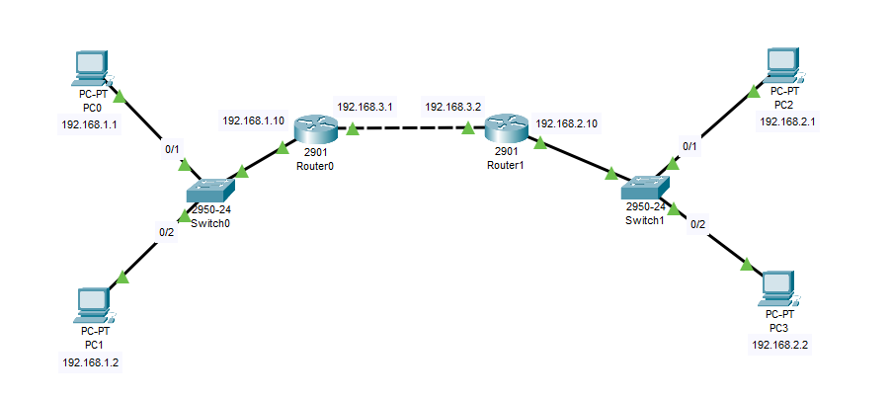

**Results.**

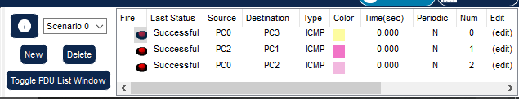

**TASK 3.**

**Topology.**

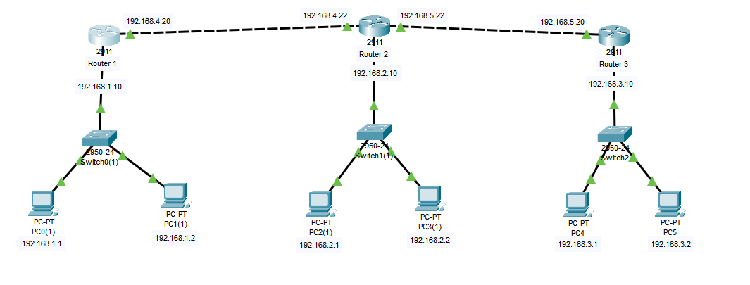

**Router 1 Static Configuration.**

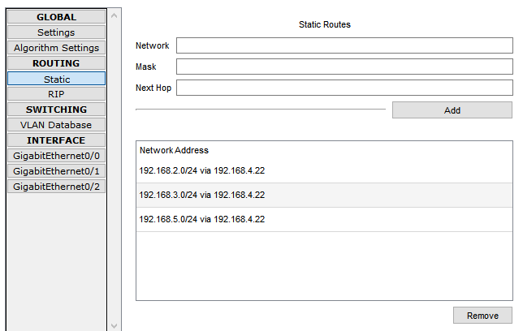

**Router 2 Static Configuration.**

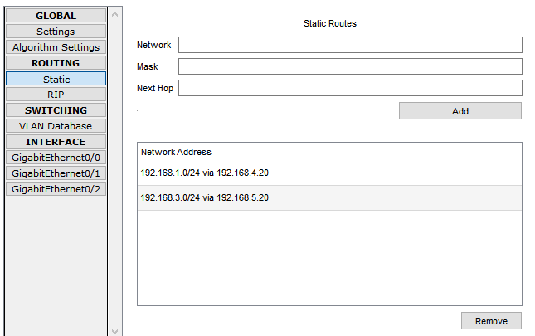

**Router 3 Static Configuration.**

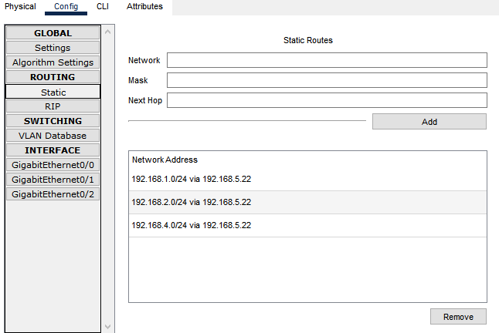

**Results.**

